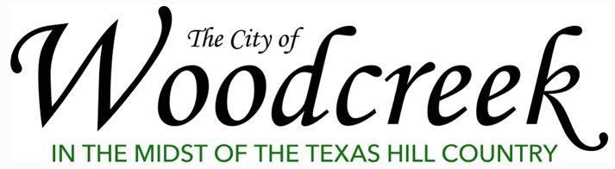
City Council Agenda Item Coversheet
Proposed Motion:
Discuss and possible action to approve the Community Relations Committee’s request to host the 2026 Music in the Park Series to be hosted on the first Friday of March (6th), April (3rd), and May (1st) at the Triangle and authorize an amount not to exceed $1,200 to be spent from the Community Relations budget to support event production.
Item Description:
Event: 2026 Music in the Park Series
Date & Time: Friday, March 6th, April 3rd, May 1st; 5pm - 7pm
Location: Triangle Park
The City of Woodcreek’s Community Relations Committee is excited to present the 2026 Music in the Park series, taking place on Fridays March 6, April 3, and May 1 from 5–7 PM at the Triangle. This free, family-friendly community event invites residents to enjoy live music from local artists, a rotating food truck, and a relaxed BYOB atmosphere. Neighbors are encouraged to bring chairs or blankets and gather for an easy, enjoyable Friday evening in the park. Music in the Park aims to foster community connection, support local musicians, and create a recurring seasonal tradition for Woodcreek families. The event is open to the public and designed to offer a welcoming, accessible way for residents of all ages to come together and kick off the weekend.
If proposing to spend money, what amount and from what budget line item?
Not to exceed $1,200 from the CRC budget line item.

